Aim: To recommend an item to the user using a content-based filtering approach
IDE: Google Colab

Theory:
There are a lot of applications where websites collect data from their users and use that data to predict the likes and dislikes of their users. This allows them to recommend the content that they like. Recommender systems are a way of suggesting similar items and ideas to a user’s specific way of thinking.
Recommender System is different types:
- Collaborative Filtering: Collaborative Filtering recommends items based on similarity measures between users and/or items. The basic assumption behind the algorithm is that users with similar interests have common preferences.
- Content-Based Recommendation: It is supervised machine learning used to induce a classifier to discriminate between interesting and uninteresting items for the user.
Content-Based Recommendation System: Content-Based systems recommend items to the customer similar to previously highly rated items by the customer. It uses the features and properties of the item. From these properties, it can calculate the similarity between the items.
In a content-based recommendation system, first, we need to create a profile for each item, which represents the properties of those items. The user profiles are inferred for a particular user. We use these user profiles to recommend items to the users from the catalog.

Item profile:
In a content-based recommendation system, we need to build a profile for each item, which contains the important properties of each item. For Example, if the movie is an item, then its actors, director, release year, and genre are its important properties, and for the document, the important property is the type of content and set of important words in it.
Let’s have a look at how to create an item profile. First, we need to perform the TF-IDF vectorizer, where TF (term frequency) of a word is the number of times it appears in a document, and the IDF (inverse document frequency) of a word is the measure of how significant that term is in the whole corpus.

User profile:
The user profile is a vector that describes the user's preferences. During the creation of the user’s profile, we use a utility matrix that describes the relationship between the user and the item. From this information, the best estimate we can decide which item the user likes is some aggregation of the profiles of those items.

Advantages and Disadvantages:
- Advantages:
  - No need for data on other users when applying to similar users.
  - Able to recommend to users with unique tastes.
  - Able to recommend new & popular items

  - Explanations for recommended items.

Disadvantages:
  - Finding the appropriate feature is hard.
  - Doesn’t recommend items outside the user profile.

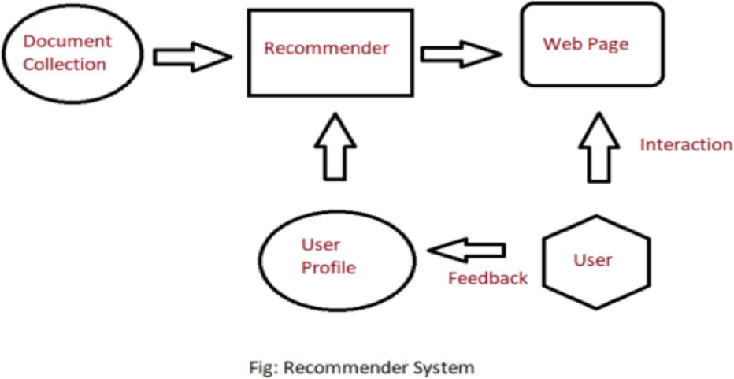

Pre Lab Exercise:
- When can you use a content-based recommendation system approach?

- Write the advantages of the content-based filtering approach

- Write the disadvantages of the content-based filtering approach

Program (Code):
import pandas as pd
from sklearn.feature_extraction.text import TfidfVectorizer
from sklearn.metrics.pairwise import cosine_similarity
df=pd.read_csv("/content/movies.csv")
#preprocessing step
df["genres"]=df["Genre"].fillna("")
df["lead_studio"]=df["Lead Studio"].fillna("")
df["content"]=df["genres"]+" "+df['lead_studio']
#TF-IDF Vectorizer
tfidf=TfidfVectorizer(stop_words="english")
tfidf_matrix=tfidf.fit_transform(df["content"])
cosine_sim=cosine_similarity(tfidf_matrix,tfidf_matrix)
#droping the duplicates
indices=pd.Series(df.index,index=df["Film"]).drop_duplicates()
def recommendation_movie(title,topn=5):
if title not in indices:
return "Movie is not found!"
idx=indices[title]
sim_scores=list(enumerate(cosine_sim[idx]))
sim_scores=sorted(sim_scores,key=lambda x:x[1],reverse=True)
sim_scores=sim_scores[1:topn+1]
movie_indices=[i[0] for i in sim_scores]
return df["Film"].iloc[movie_indices]
recommendation_movie("Twilight")

Results:

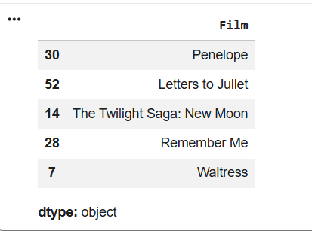

Observation:

Post Lab Exercise:
- What changes do you feel can be done to improve the system that you have designed, as part of an in-house lab exercise?
Improvements to the System
  - The following improvements can be made:
  - Use more features (director, cast, ratings)
  - Apply advanced embeddings (Word2Vec, BERT)
  - Combine with collaborative filtering (hybrid system)
  - Add user feedback (likes/dislikes)
  - Improve diversity in recommendations
  - Use deep learning models for better accuracy
- Recommend top-10 “series” using IMDB movie dataset
(Link: https://www.kaggle.com/datasets/harshitshankhdhar/imdb-dataset-of-top-1000- movies-and-tv-shows). Attach the code to the output. Also, write your observation for the same.
Code:
import pandas as pd

df = pd.read_csv("/content/imdb_top_1000.csv")
df = df.dropna(subset=["IMDB_Rating", "No_of_Votes"])
df["No_of_votes"] = df["No_of_Votes"].astype(int)
C = df["IMDB_Rating"].mean()
m = df["No_of_votes"].quantile(0.90)

def weighted_rating(x):
v = x["No_of_votes"]
R = x["IMDB_Rating"]
return (v/(v+m)*R) + (m/(m+v)*C)

df["score"] = df.apply(weighted_rating, axis=1)
top10 = df.sort_values(by="score", ascending=False).head(10)

print(top10[[
"Series_Title",
"IMDB_Rating",
"No_of_votes",
"Genre",
"Director"
]])
Output:
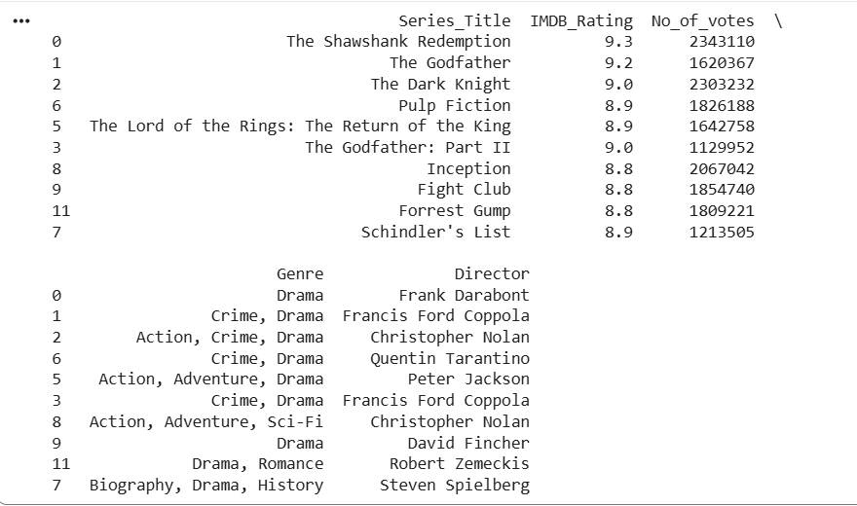
The results obtained from the recommendation system highlight the top-rated titles based on IMDb rating and number of votes, using a weighted scoring approach. From the table, it is evident that all the selected titles have very high IMDb ratings along with a large number of votes, indicating strong audience approval and reliability. A clear observation is that the dominant genre, as almost every title includes Drama either as a primary or secondary genre. This suggests that drama-based content tends to receive higher audience appreciation and critical acclaim.

